- Install nginx and run nginx on port number 81


- Deploy a sample index.html file on nginx.



.

- Install Apache and run Apache on port number 82
- Deploy a sample index.html file on Apache.

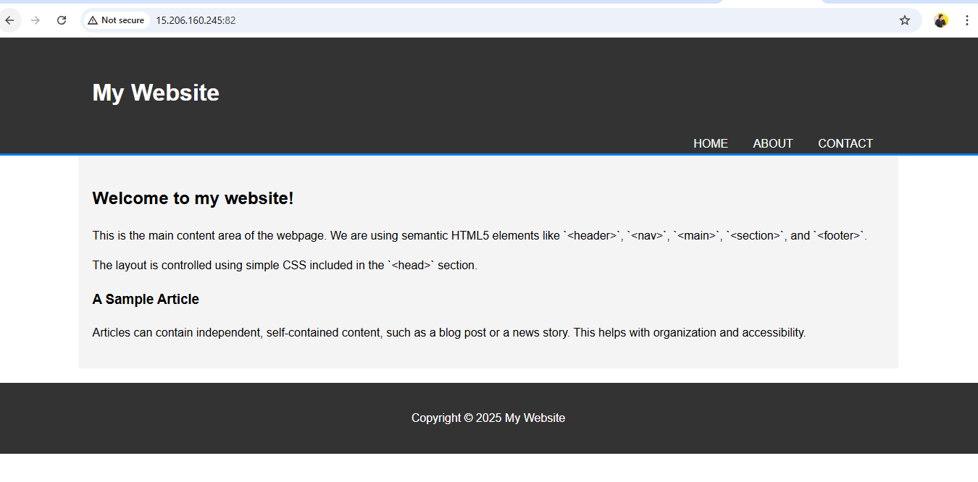

- Install Apache tomcat on port number 8082

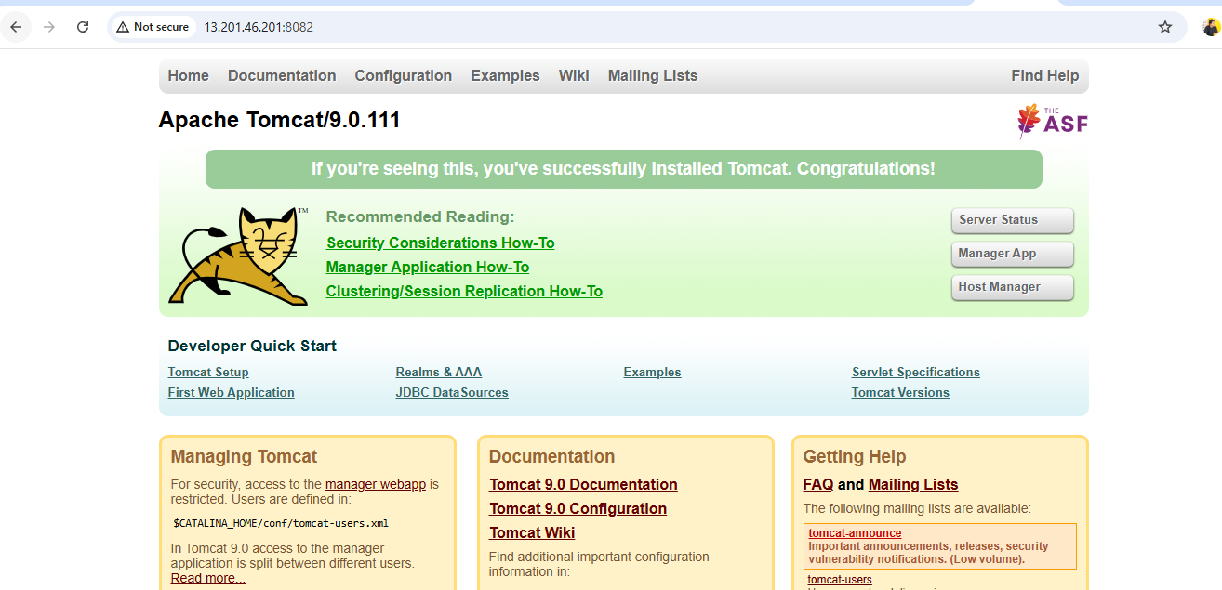

- Deploy a sample app on webapps

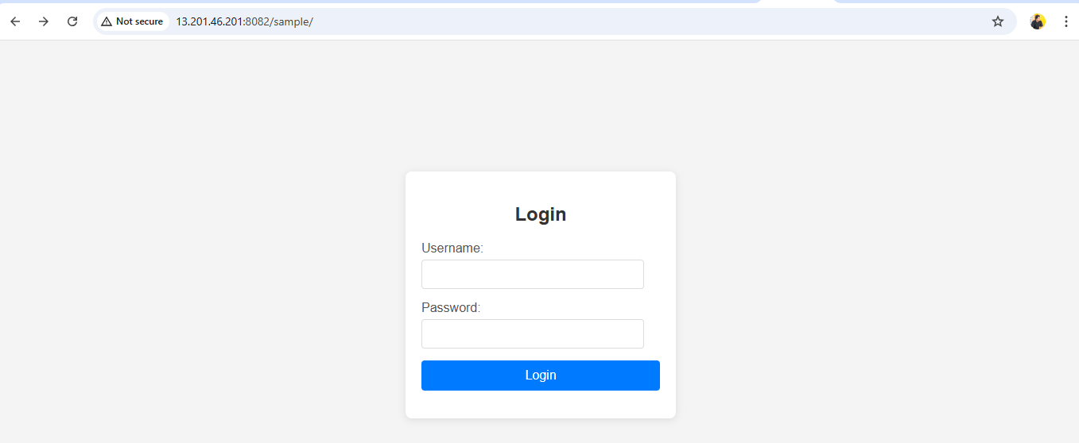

- Create a tomcat.service file for tomcat.
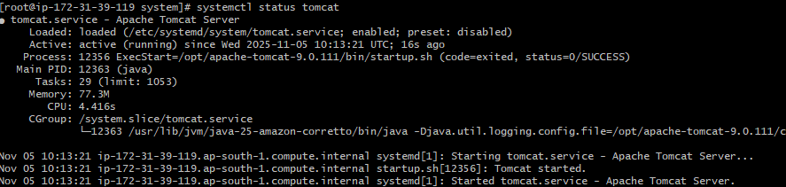

- Configure HA Proxy server

Working on server-1 public id



Working on server-2 public id



Working successfully on Haproxy public id


